Mark F. Horstemeyer, Giles Distinguished Professor and CAVS Chair Professor
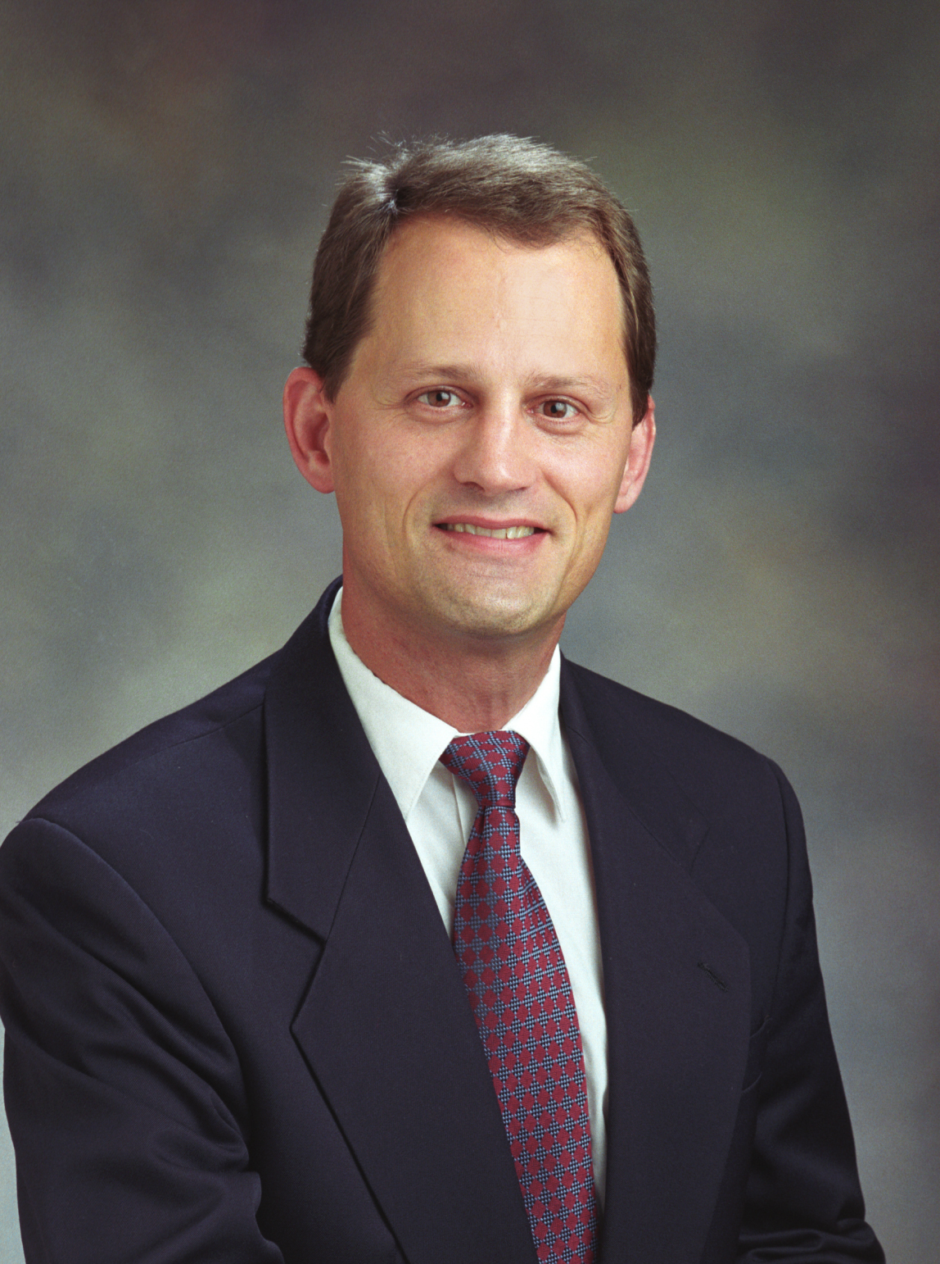

As a fellow of four societies (ASME, ASM, SAE, and AAAS) Dr. Mark F. Horstemeyer has garnered national and international acclaim as he has published over 400 journal articles, conference papers, books, and technical reports with a citation impact h-factor of 46 with a total of over 7200; he has been invited to give over 150 lectures throughout the world (was named as honorary professor of Xihua University, Chengdu, China); and has won many awards (R&D 100 Award, AFS Best Paper Award, Sandia Award for Excellence, Ralph E. Powe Research Award, Ohio State’s Thomas French Alumni Achievement Award); and has mentored over 120 graduate students and post-doctoral researchers. He has started three start-up companies in trying to put predictive science into engineering designs: Predictive Design Technologies, LLC; Advanced Technology Associates, LLC; and Rush Predictive Protective Systems, LLC. He earned a B.S. degree (with honors) from West Virginia University in Mechanical Engineering in 1985, a M.S. degree from Ohio State University in Eng. Mechanics in 1987, and a Ph.D. from Georgia Institute of Technology in Mech. Eng. and Math & Matls (minors) in 1995. He is currently a professor in the Mechanical Engineering Department at Mississippi State University (2002-present) holding a Chair position for the Center for Advanced Vehicular Systems (CAVS) in Computational Solid Mechanics and the Chief Technical Officer for CAVS. Before coming to MSU, he worked for Sandia National Labs for fifteen years (1987-2002) in the area of multiscale modeling for design. He couples multidisciplinary research of solid mechanics, materials, physics, and applied mathematics in three synergistic areas: theoretical modeling, experimentation, and large scale parallel computational simulation. In terms of theoretical modeling, this area develops and employs techniques that capture structure-properties from the quantum scale to the large structural scale in order to simulate the history of a material in order to predict life cycle performance of structural components. In terms of experimentation, CAVS is developing a state-of-the-art facility for applied mechanics, manufacturing, and materials characterization for multiscale exploratory experiments, model calibration experiments, and simulation validation experiments. His plan is to infuse these methods into engineering practices. A broad and novel educational program featuring design throughout the curriculum is proposed for graduate and undergraduate students giving rise to a diverse group of future engineers/scientists working together at CAVS. Dr. Horstemeyer has also provided outstanding training opportunities for the next generation of scientists and engineers growing the MSU Mechanical Engineering program from several graduate students to approximately 100 today (in 12 years).

As the first CAVS Chair professor since the center opened in 2002, Dr. Horstemeyer was instrumental in creating the scientific and technology foundation for the southern automotive corridor of the nation by setting forth a vision for simulation based design and manufacturing related to the automotive industry that has developed. His work has helped bridge the valley of death from research to industrial application by building a culture of technology transfer where research by scientists is more integrated with engineers in the auto industry.

Recently, Dr. Horstemeyer has focused on nature’s methods of mitigating shock and absorbing energy by analyzing turtle shells, sea shells, armadillo shells, woodpeckers’ beaks, and rams’ horns. In doing so, he has scientifically quantified the different mechanisms that mitigate shock and absorb energy and has developed engineering designs and systems to do the same. In particular, he and his current team are in the process of developing the next generation football helmets in order to reduce concussions.

